Unit 2 Project: Discovering a Formula for Counterexamples

- You will be using these examples of counterexamples
and the conjectures they disprove
to discover a rule about counterexamples.
- The “formula” will tell us how to check the choices to see if they are counterexamples.
- The “formula” will relate the counterexample to the conditional statement.

Before the Project:

Definitions:
Which words should you define before you can start this project? Define them here.
1)

2)

3)

Example of a counterexample:

Conjecture- All girls are pretty.
Counterexample-


Part 1: Identify the Counterexample for each Claim

Example Question:
Claim- All girls are pretty.
Find the counterexample to the claim that all girls are pretty.
a) Jessica Alba b) Taylor Lautner c) Ugly Betty d) this guy
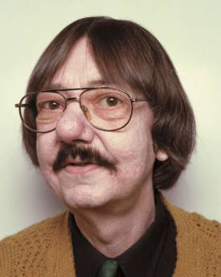

Example Answer:

- not a counterexample. She is a pretty girl so she proves the claim.
- not a counterexample. He is a boy, so the claim wasn’t talking about him. He is irrelevant.
- COUNTEREXAMPLE. She is a girl so the claim says she is pretty, but she’s not. She is a counterexample.
- Not a counterexample. He is a boy, so the claim is not about him. He is irrelevant.

Part 1: Identify the Counterexample for each Claim

Find the counterexample for each claim. Explain each choice like I did in the example.

1) All babies are cute.

a) pretty adult b) ugly baby c) pretty baby d) pretty puppy


2) All girls have long hair.

- a boy with long hair

- a girl with long hair

- a girl with short hair

d) a boy with short hair

3) All basketball players are tall.
a) Yao Ming b) #11 on the Nuggets c) Kobe Bryant d) this tall guy who
doesn’t play basketball.


4) Cartoons are for kids.
a) The Smurfs b) Family Guy c) Power Rangers d) Suite Life on Deck



5) If you can use it to travel on the freeway, then it is a car.

a) a car b) a plane c) a skateboard d) a motorcycle

Part 2: Developing a Rule for Counterexamples

Your job:

Make a general rule about what is required to be a counterexample?
Start by looking at the relationship between the answers to every question above.
What do you notice?

Your rule:
You MUST relate the rule to the conditional satetement.

Your thought process:
What kind of reasoning did you use to find the rule? Inductive or deductive?
Explain your answer.

Steps/Scaffolds: Turn the claims into conditional statements.
Underline the hypothesis in each.
Circle the conclusion in each.
Determine whether each option is true or false in terms of the
hypothesis.
Determine whether each option is true or false in terms of the
conclusion.
Look for the pattern among the counterexamples.
Find some patterns among the other options and use them to
assign a category to the groups of options.

